Outdoor sports intercom
- Product Overview
The WS-T1S walkie talkie is a communication device designed for outdoor sports applications. With just one click, you can quickly team up on the same frequency and chat with up to 1000 people. It also supports 5000 kilometers of intercom, making outdoor sports more fun and reassuring.
- Application scenarios
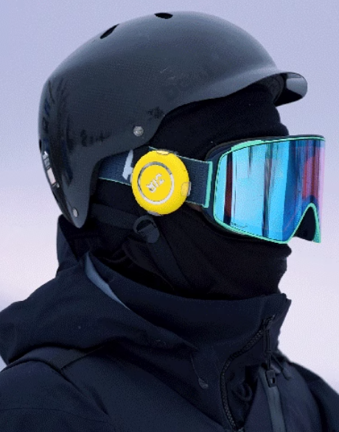
Glasses helmet around the neck

Can be applied to outdoor activities such as cycling, mountain climbing, skiing, hiking, and tourism, reducing communication pressure.
- Product features
- Point to point wireless intercom (1000m)
- AI intelligent voice assistant
- GPS location sharing
- -40 degree low-temperature resistant battery
- 5000KM public intercom
- One click same frequency quick team formation
- Product Parameters
parameter | description
size | 6*6*1.65cm
weight | 45g
Communication Mode | 4G/point-to-point
Two-way talk distance | 5000 km (public network)  1000m (point-to-point)
classification of waterproof | IPX6
cell | Heat-resistant battery
duration of flight | 10h
Standby time | 48h
fittings of a machine | Magnetic ring, anti-loss rope, back clip

